**PYTHON INSTALLATION by add the path**

Step 1:- we need to find the latest update of the python depends on your current operating system (Window’s, Linux and Mac os)

For that

Step 2:-we have a web browser called Google chrome or any else like (Mozilla

Firefox and opera etc….). In the web browser search the word “python”

As follows

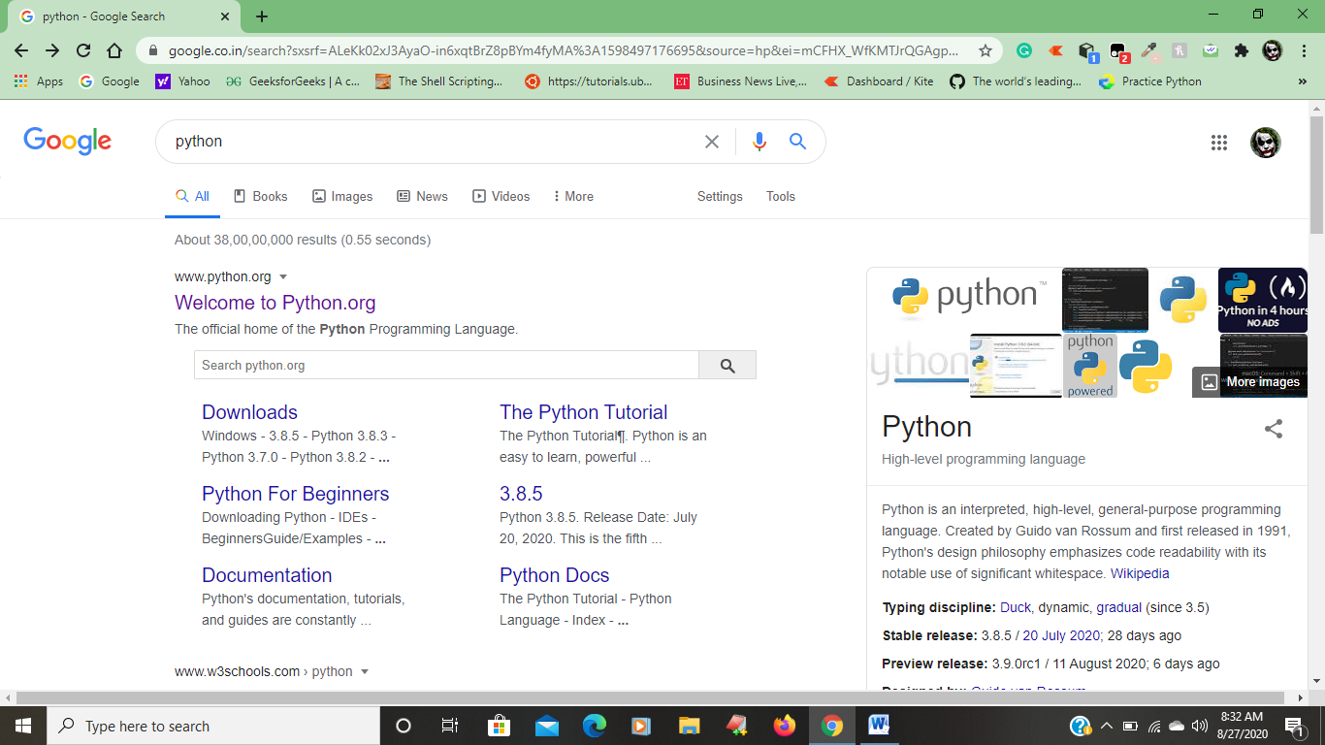

After that click on the first link of the page [www.python.org](http://www.python.org) that will shows as below.

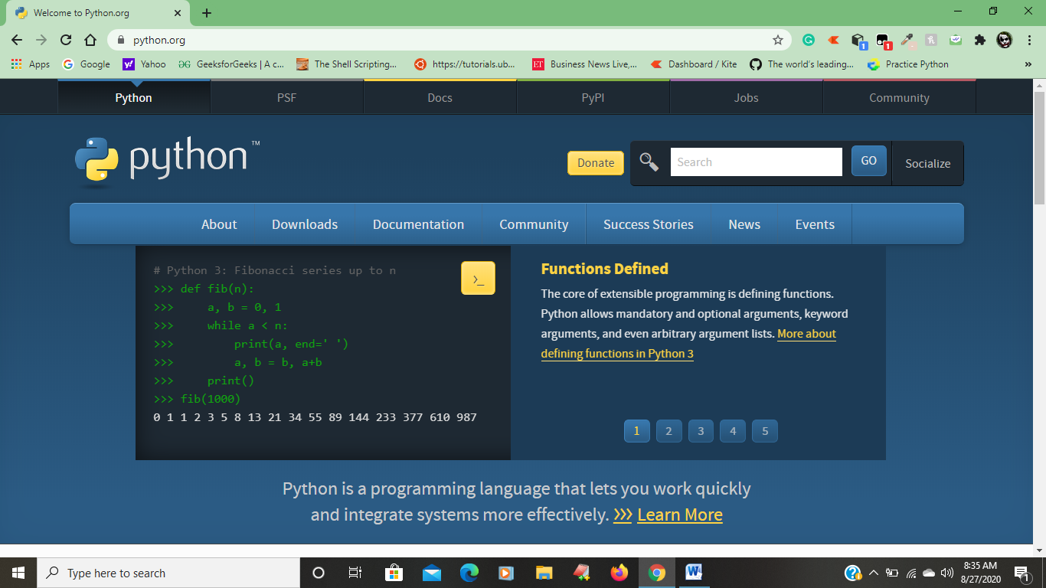

After that click on the downloads button that shows as below.

In that you will find the latest version of the python.

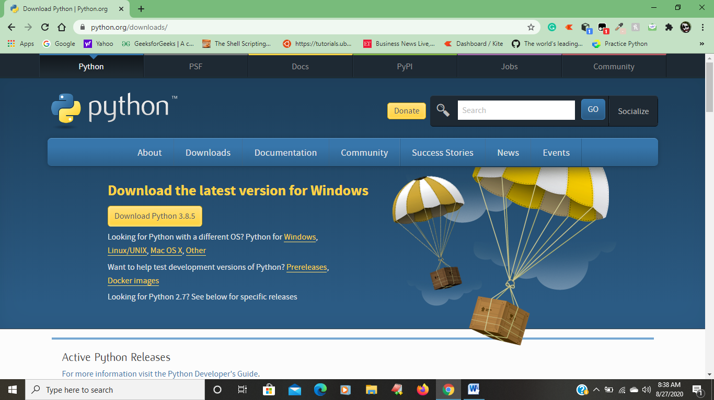

We need to pick the latest version of the python according to your current operating system

If you have windows operating system click on the “download python 3.8.5 “then it will download the current version of python into your window’s pc

Step 3:- After downloading the latest version of python double click on the

Python S/w then it will shows as blow.

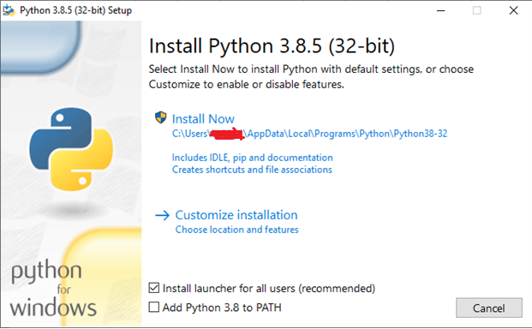

In python there is a special advantage it automatically set the path by click the Check box as shown below

**Why we need to set the path brief explanation**

PATH is an environment variable in Windows. It basically tells the command line what folders to look in when attempting to find a file. If you didn't add Python to PATH then you would call it from the command line like this: C:/Python27/Python

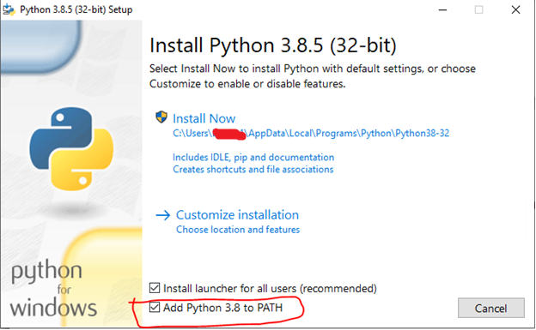

After that click on the install now if u want the location where the python was save as shown below

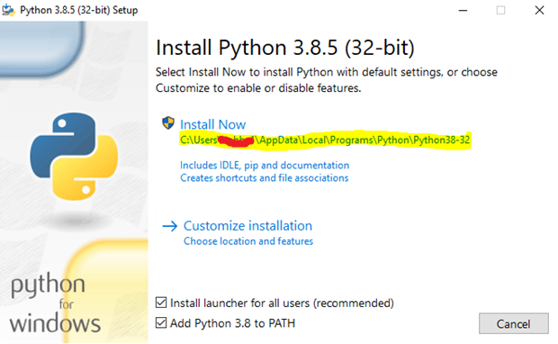

After click on install now then windows verification permission will appear. In that windows verification permission all the detail of this software will be placed on that window.

After checking the detail of your software in the windows verification permission click on “yes”.

Then the python software start installing in the pc as shown below.

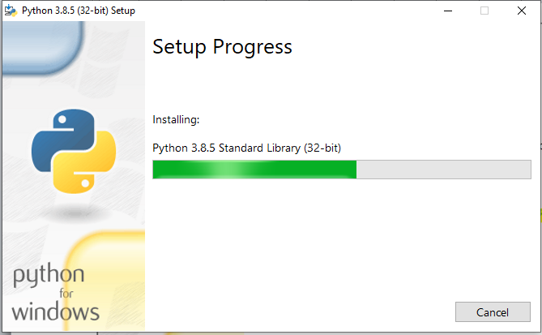

The above process will take up to 3 minutes

After that the python will completely install as shown below

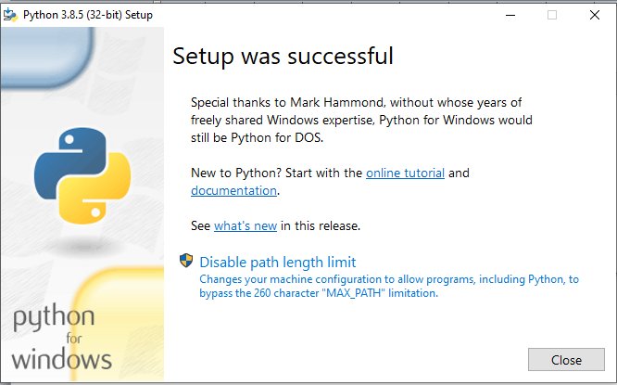

Step 4:- After the python software install completely. Checking that the python

Software installed or not

There are two way to check whether the python software successful installed or not.

* The first way is checking that the idle(integrated development learning environment) of python is in your pc it also call as python shell.
* If you want to find python shell in your pc click on start or windows button as shown bellow

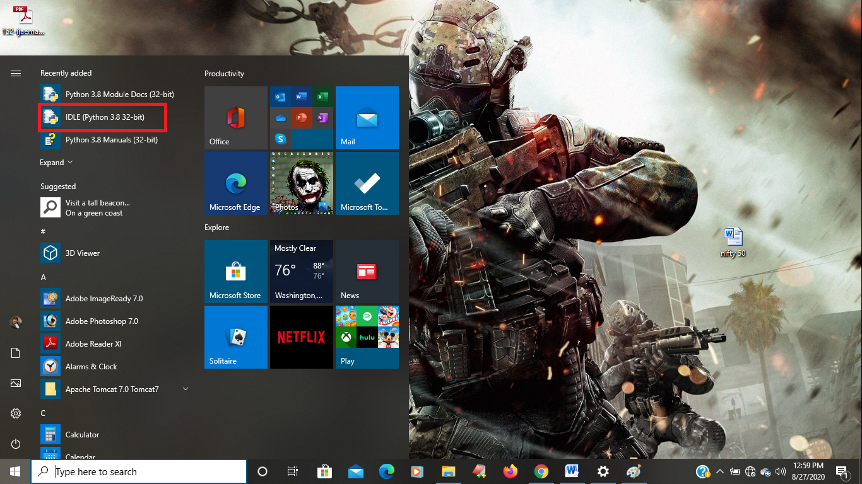

* In the above figure how the python shell will be as marked
* This is a way to find that the python is in your system or not
* The python shell will as shown below.

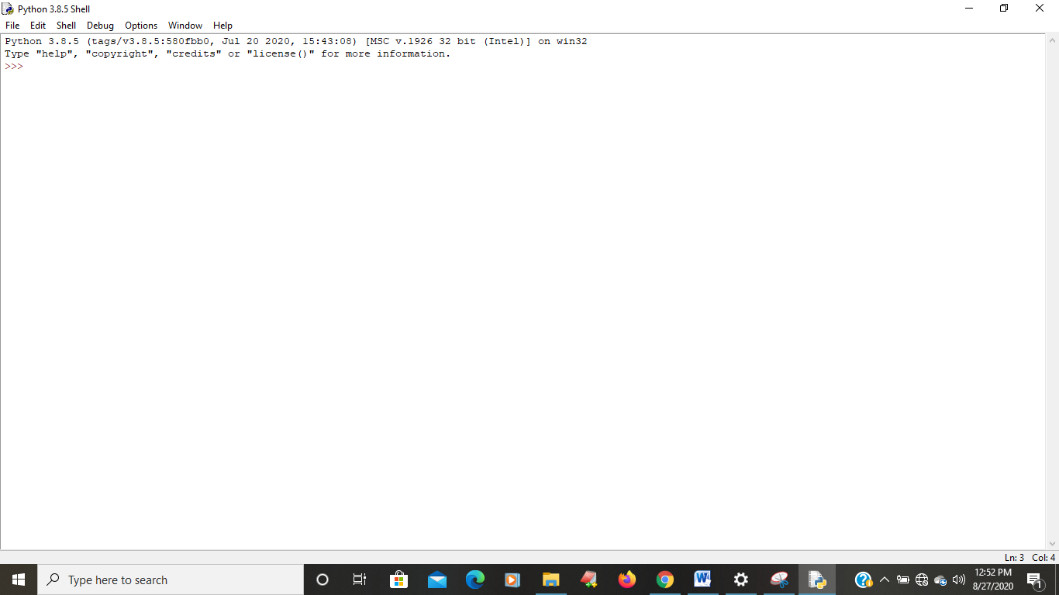

The another way to find python in your system are not

* By using command prompt or cmd to open cmd click windows button and search command prompt

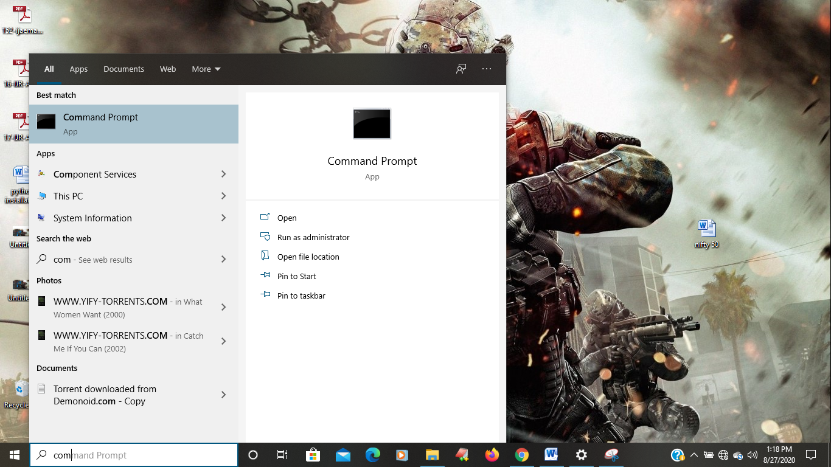

* Shortcut (windows+r) then it will open as shown below
* 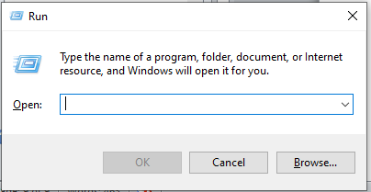
* And type cmd in search bar and ok
* 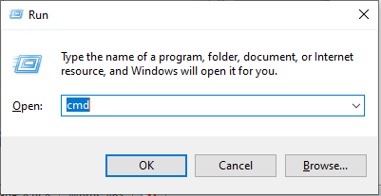
* After that command prompt will open as shown below
* 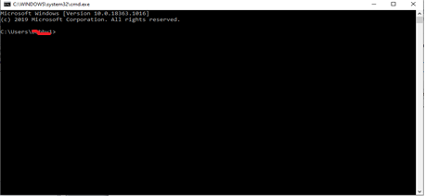
* Then type python or py.
* 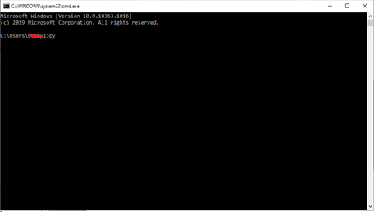
* Click enter then python was loaded into the command prompt as shown below
* 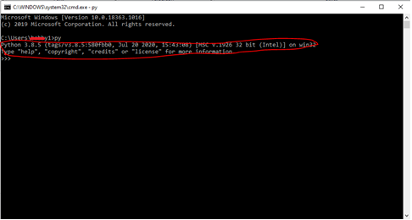

In this way we can install or check the python in your pc